**TITLE:** Retail Store Stock Inventory Analytics

**Name:** M.S.Tamilarasan

**Team ID:** PNT2022TMID15244

Upload the dataset to Cog Analytics, explore and visualize the

dataset

1. **Uploading Dataset to IBM Cognos Analytics:**

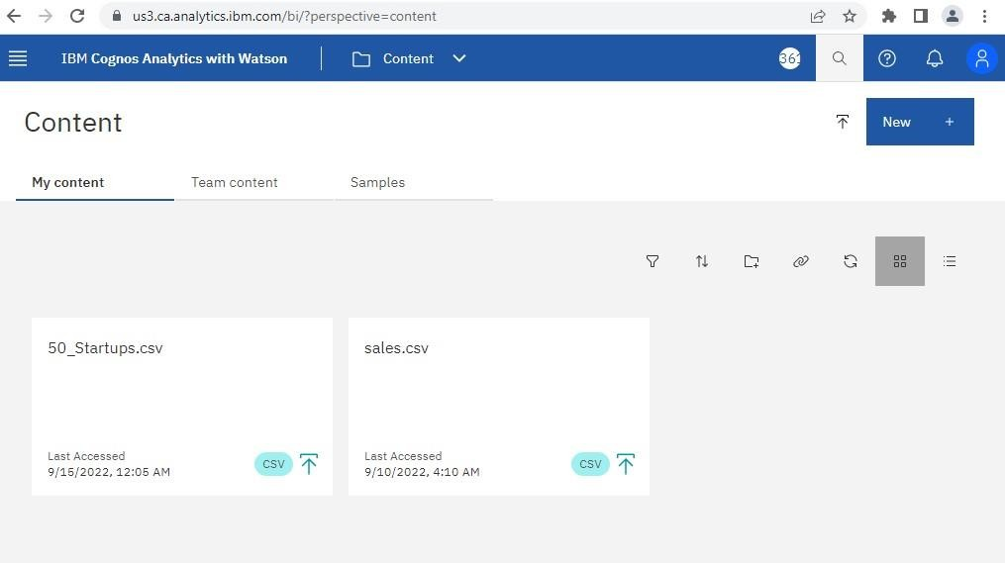

1. **Data Exploration:**

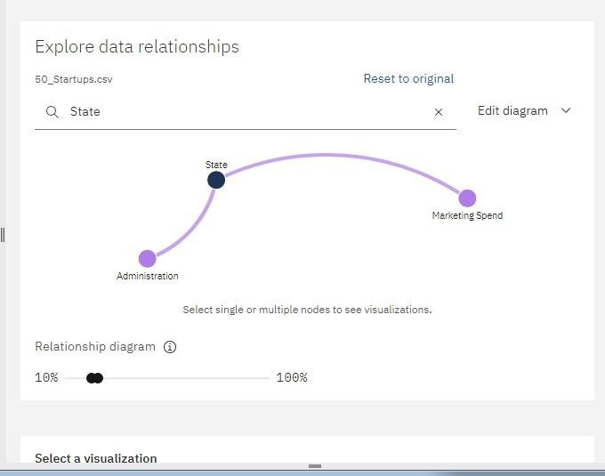



State Compared To Administration and Marketing Spend

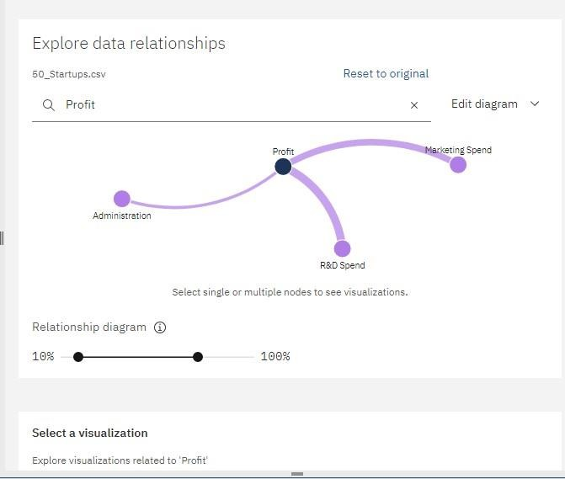



Administration,R&D Spend, Marketing Spend Compared To Profit

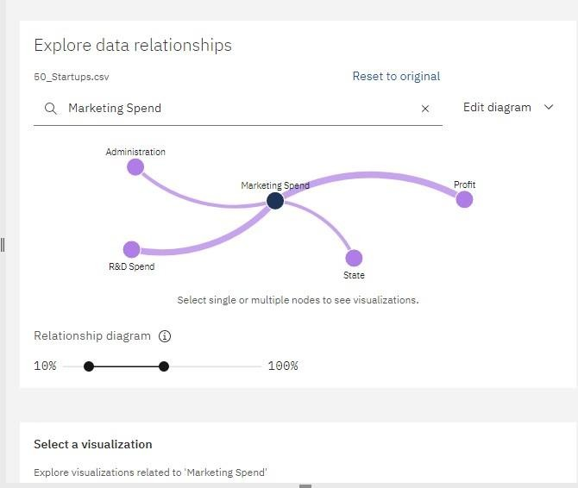

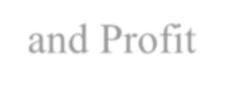

Marketing Spend Compared To State ,Administration,R&D Spend

and Profit

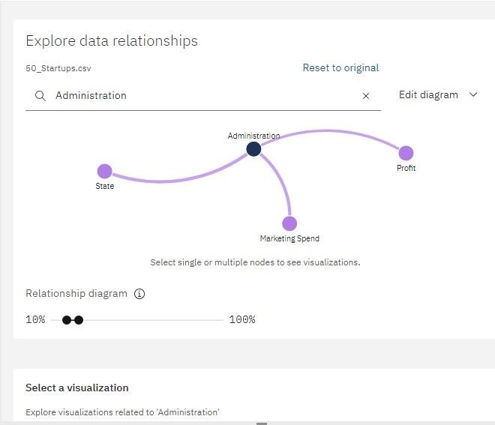



Administration Compared To, Marketing Spend,State and Profit

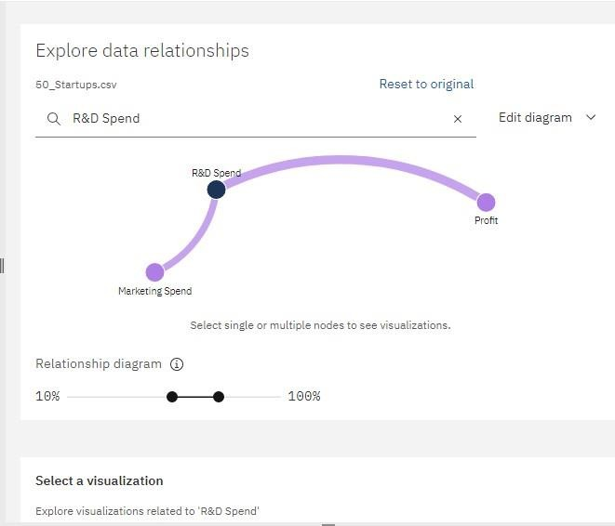



R&D SpendCompared To Marketing Spend,



and Profit

1. **Data Visualization:**

Bar chart Representation:

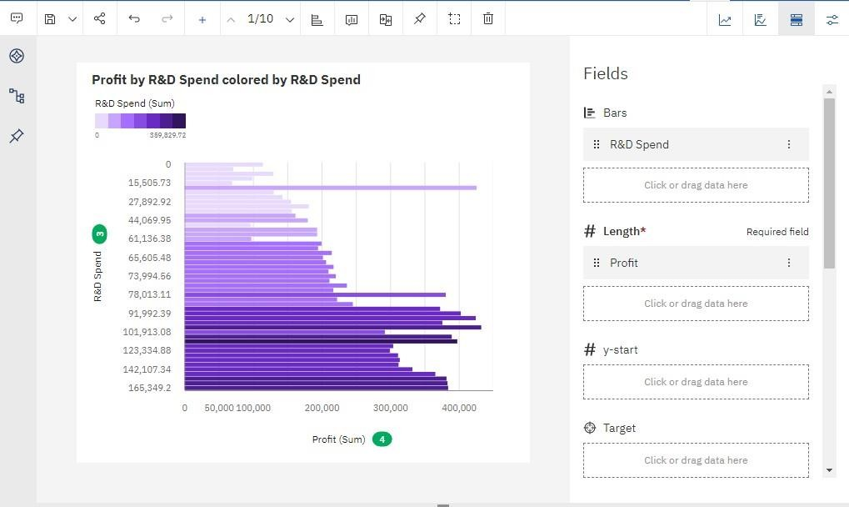



Bar chart for Profit to R&D Spend

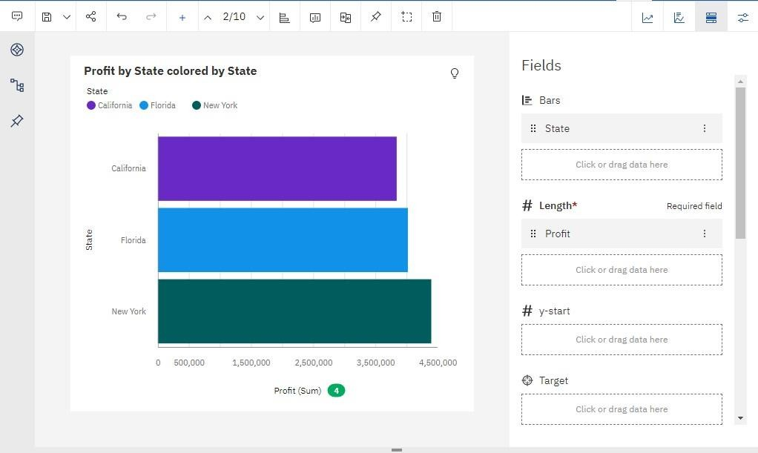



Profit Compared to State

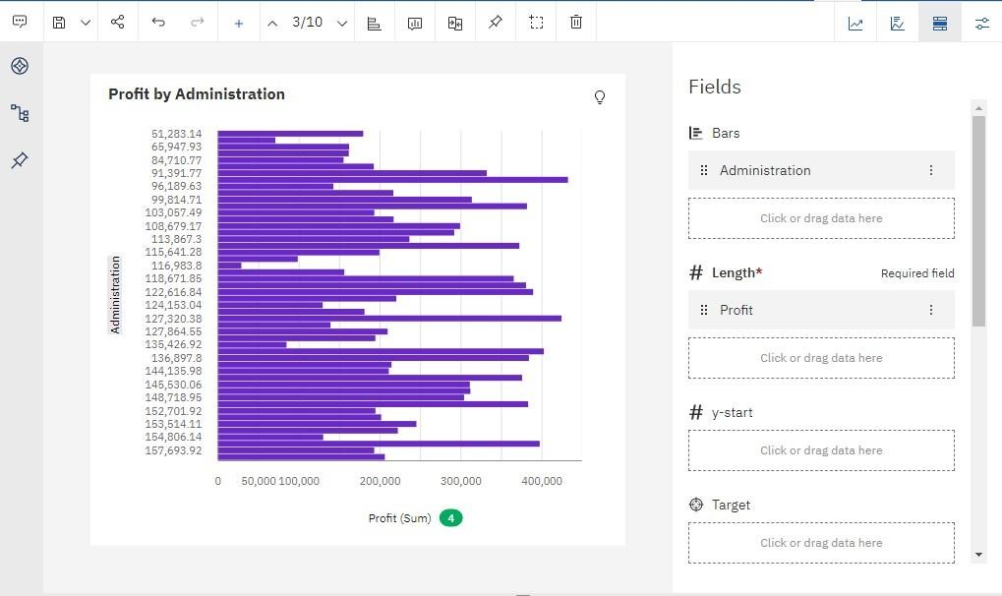



Profit Compared to Administration

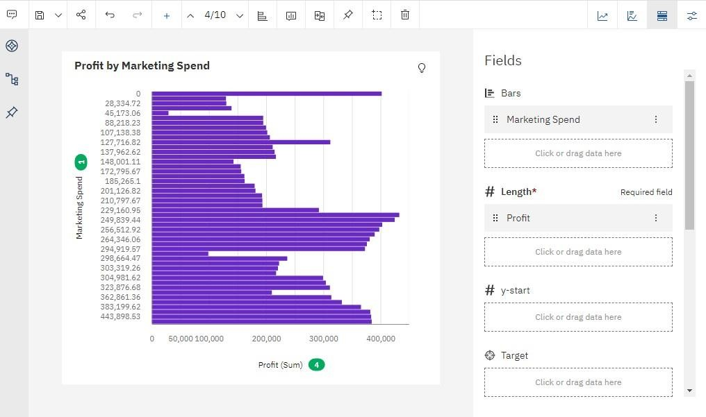



Profit Compared to Marketing Spend

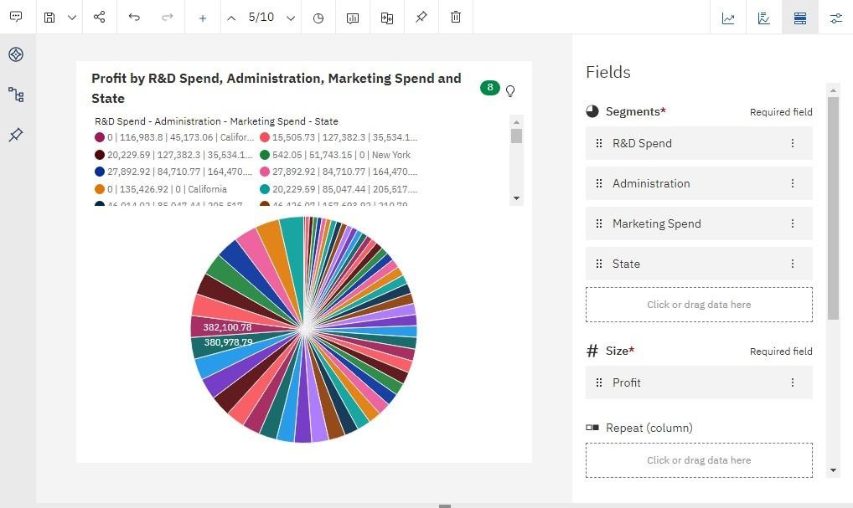Pie Chart Representation:

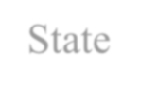

Profit Compared to R&D Spend,Administration,Marketing Spend and

State

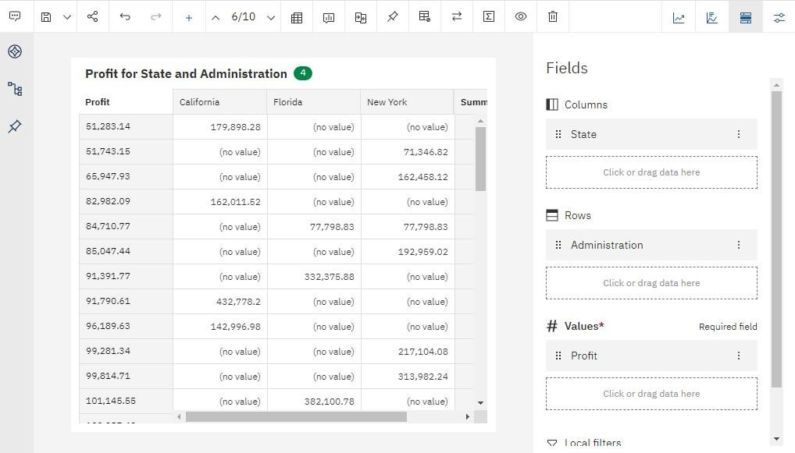

Profit For State and Administration

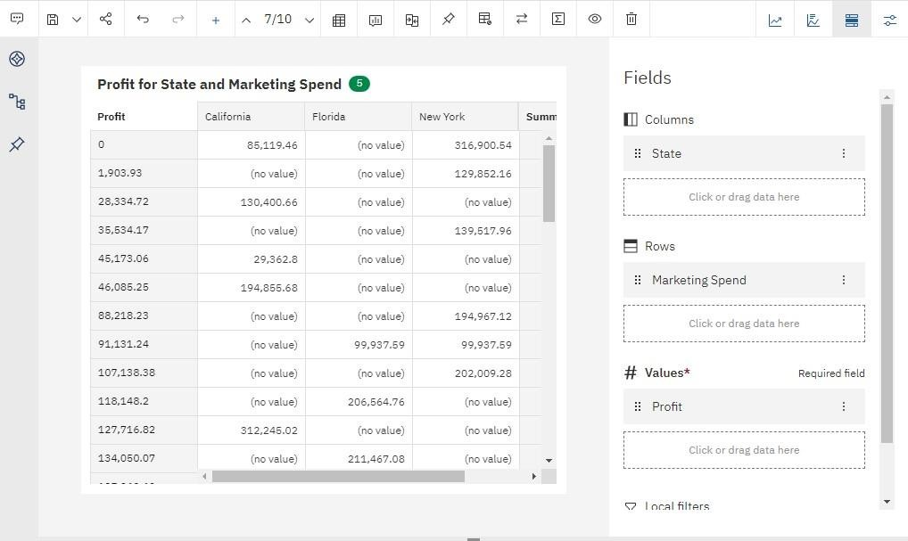

Profit For State and Marketing



Profit For State and Marketing Spend

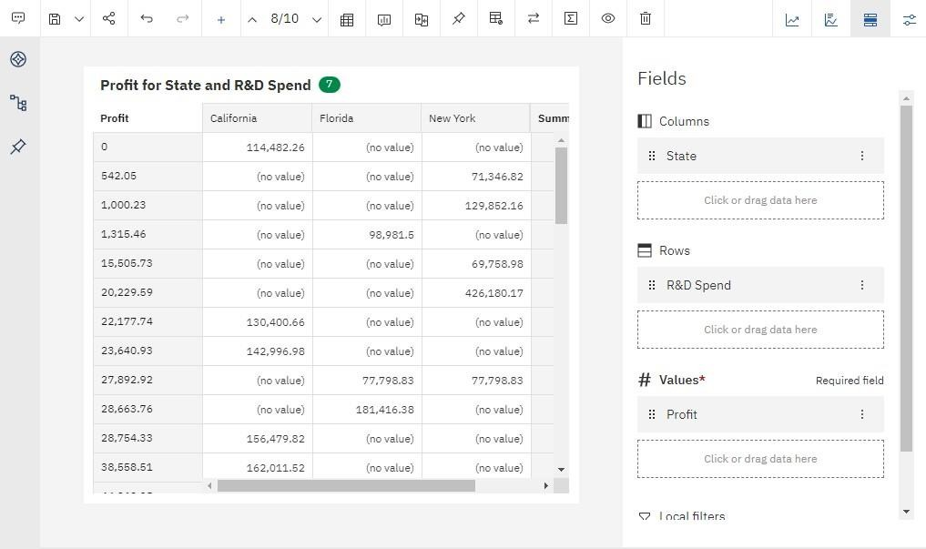

Profit For State and R&D Spend

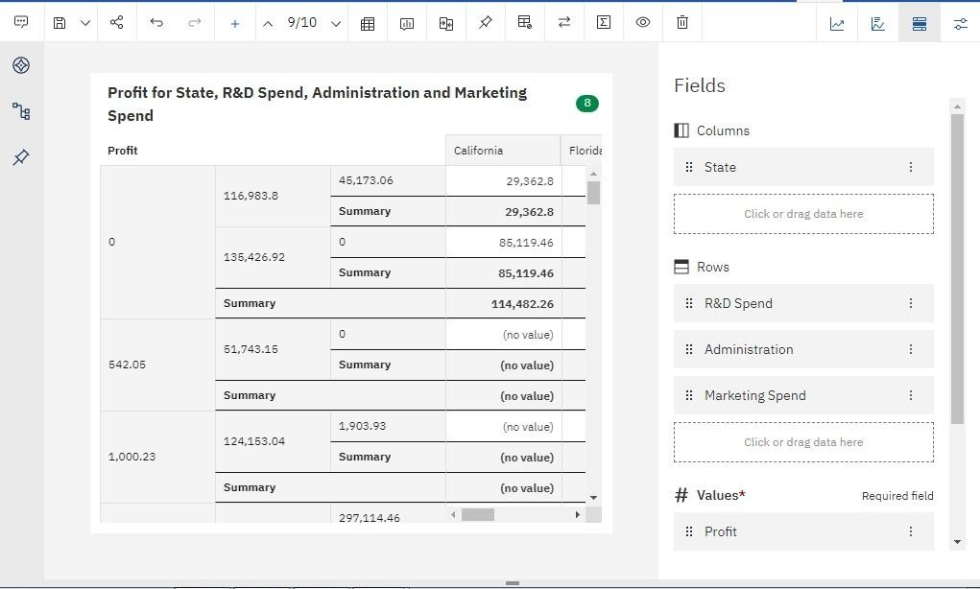

Profit For State,R&D Spend,Administration and Marketing Spend